COSC363 Assignment 2: Ray Tracing
Harry Dobbs 89030703

Overview:
A ray tracing algorithm has been implemented to create a realistic scene. The scene includes a wide variety of shapes and effects. The scene accurately utiilizes features such as transparency, refraction, shadows, rotation, reflection,textures and specular highlights. These features combined with the use of various shapes create a visually spectacular scene. Fog is turned on by pressing the key ‘f’. Fog is turned off by pressing the key ‘c’. There is a delay when switching between the two states.
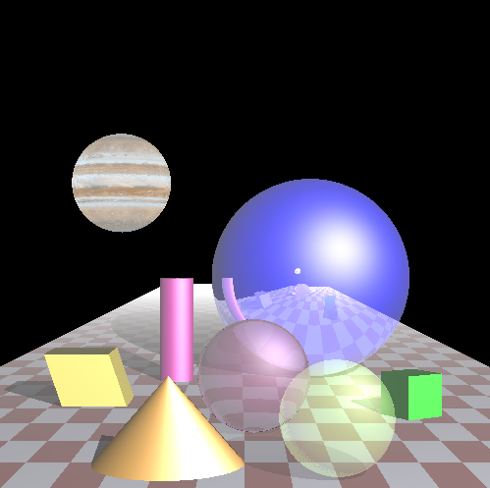Figure 1: Ray tracing scene with fog turned on.
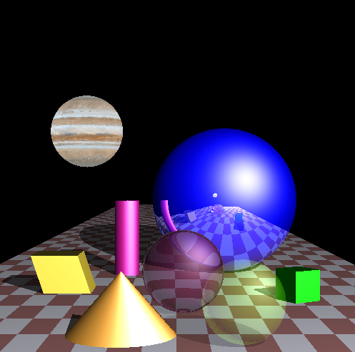Figure 2: Ray tracing scene with fog turned off

Standard Features (9 marks):
- Contains one light source aswell as diffuse, and specular reflections generated by the source.
- Contains shadows for every object. Transparent objects create a lighter shadow.
- The scene contains one large blue reflective sphere.
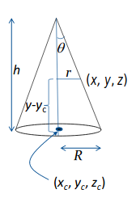
- The scene contains two boxes. One is skewed and one is regular.
Equation 1: Every point on cone must satisfy this equation.
Figure 4: Diagram illustrating the location of each point.
Equation 2: Ray equations.
- The scene contains a chequerd floor.

Additional Features (7-9 marks):

Primitive Cone (1 mark) :
To be able to display a cone within my assignment, each ray must be able to calculate:
- If it has intersected with the cone
- The normal vector at the point of intersection
These two requirements were constructed as functions. To be able to implement these fucntions, geometric equations were required. The equations for a cone, and cylinder accompained with labelled diagrams (Figure 5) were provided from the lecture notes (Mukundan ,2019). The points of intersection are obtained by substituing the ray equations (Equation 2) into the general point equation (Equation 1). The resulting equation is then solved for t. An issue I had with the original implementation was that a second cone was generated on top of the cone I wanted to display (Figure 3). This issue was resolved by substituing the value of t into the Y ray equation (Equation 2) and ensuring the height was less then the summation of the cone centre plus the height of the cone (Figure 4). A similar method was used to constrain the minimum height of the cone (Figure 4). The normal vector is important to ensure the object is lit correctly. To obtain the normal vector Equation 3 was implemented.
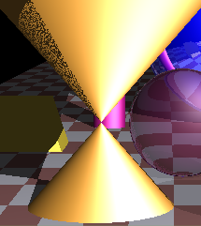Figure 3: Image of incorrectly implemented cone.

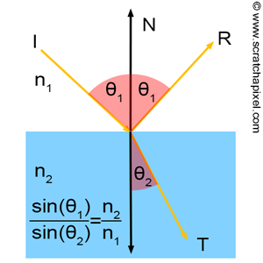Figure 9: Image demonstrating Refraction (Scratchpixel 2014)
Equation 4: Pixel colour equation for refraction

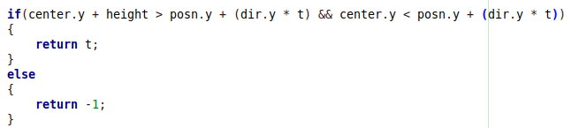Figure 5: Equation implementation to ensure cone in contained with certain values of Y.
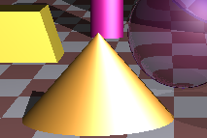Figure 6: Image Capture of Cone Implementation

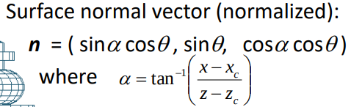Equation 3: Surface normal vector equation for cone

Transparent Object (1 mark) :
When an object is transparent an additional ray in generated in the same direction as the ray that intersected with the transparent object. However this ray’s origin is on the other side of the transparent object. The pixel colour that is displayed to us is a result of the transparent object colour multiplied by some transmission factor summed with the colour returned from the additional ray. An issue I had with the implementation is that sometimes the origin of the additional ray is the at the same point the original ray contacts the object (as shown by red arrow in Drawing 1) as opposed to being on the other side of the object (as shown by blue arrow in Drawing 1) . This issue was relatively to simple to resolve and once resolved the transparent object edges looked cleaner. This issue was resolved by testing wether the additional ray intersected the sphere or another part of the scene. Depending on wether it hit the sphere or another part of the scene it would either generate another ray or return the colour value of the ray.
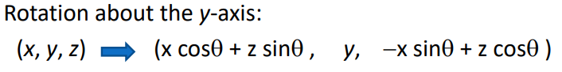
Equation 5: Shear Equation for Cube
Equation 7: Image X Coordinate Equation
Equation 8: Image X Coordinate Equation
Drawing 1: An Illustration demonstrating two scenarios when dealing with transparent objects.

Refraction of Light (1 mark) :
Refraction occurs when light travels through a transparent medium to another medium and the light is bent around a boundary. Light travels at different speeds in different mediums. Different mediums have different indexs of refraction. GLM has a function that takes the direction vector, normal vector and the ratio refractive indicies. This function will return a vector that is pointed in the refracted direction (Ic) . This vector is then traced. The colour of the pixel of given by Equation 4 where Ic is the refracted vector, pt is the scale factor (<1) and Ia is the ray that hits the refractive medium.
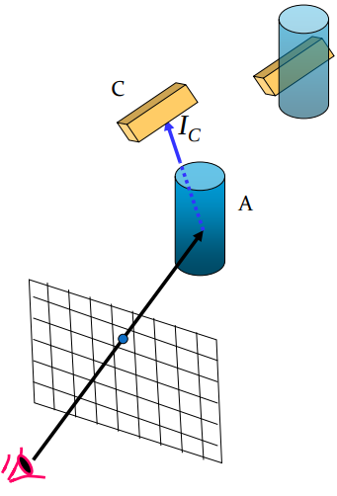Figure 7: Refraction example from COSC363 Lecure Slides (Dr. R. Mukundan ,2019)

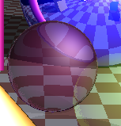Figure 8: Refractive Sphere in scene.

Rotation or Shear Transformation (1-2 mark) :
Equation 9: Implementation of fog on the red component
Equation 10: Implementation of fog on the blue component
Equation 11: Implementation of fog on the green component
The scene implements the rotation of one cube and a shear transformation on another. The Implementation of a shear transformation on a cube is rather trivial. I created a shear of the cube along the X direction. This was done by shifting all the upper points of the cube, along the X axis in the negative direction. To implement this shift I used basic trigonometry to shift the upper vertices by an amount dependant on the shear angle (Equation 5). Where H is the height of the cube and Phi is desired shear angle.
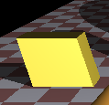Figure 10: Shear Transformation of a Cube
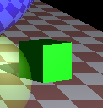Figure 11: A cube rotated 45 degrees around the Y axis.

Another cube was rotated 45 degrees around the Y axis. In order to achieve this the cube was generated at the origin of the scene. Every vertice underwent a transformation as described in the lecture slides ( Dr. R. Mukundan ,2019) . This transformation involves every vertice being multipled by a rotation matrix. This results in every point undergoing a transformation. The effect of multiplying by a rotation martrix has the same effect as applying Equation 6 to each vertice. Once each point has been rotated around the origin, each point undergoes a translation which is done by adding a position vector to each vertice.

Non-planar Object Texturing (1 mark) :

Equation 6: Rotation around Y-axis transformation formula. Theta determines how much the object rotates.
I implemented the texturing of Jupiter onto a sphere. The image of Jupiter was found online from an opensource website (Solar Textures, 2019). To display an image on a sphere the sphere must have its longitude and latitude coordinates mapped to the x and y coordinates of the image. To implement this texturing first a unit vector is made between where the ray hits the sphere and the centre point of the sphere. This unit vector’s componenets are then substited into the following equations.

These equations return the point on the texture that will be mapped to the point the ray contacted.

Fog Implementation (1-2 mark) :
I have implemented fog which can be toggled on and off (Figure 1, Figure 2). The amount of fog is equivalent to the fog density multiplied with the distance. As the amount of fog increases the pixel colour gets closer to white. When the distance at a certain point is equal to the maximum distance it can be obverseved that the equations will equate to a value of 1 (white). When the distance is very small the equations will equate to an equation that is very close to the original colour
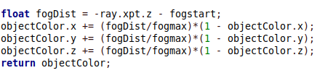Figure 12: Code snippet of fog implementation

Primitive Cylinder (1 mark) :
A cylinder object was implemented into the scene. The intersection equation (Equation 8) was avaliable from the lecture slides (Dr. R. Mukunda ,2019). This equation was solved for t to find the points of intersection. Just solving for t will give a cylinder of infinite height. This problem was resolved by constraining the t values based on their predicted heights (similar to the sphere). One issue I had with displaying the sphere was that the top of the sphere was not visible. This was resolved by reaarangling equation the ray equations in order to calculate the predicted height of the cylinder.
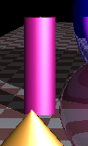Figure 13: Cylinder object in scene
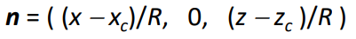Equation 9: Normal Equation for cylinder

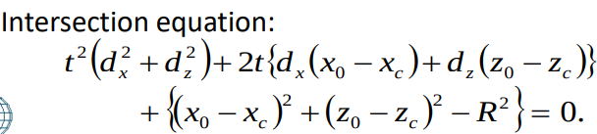Equation 8: Intersection equation for a Cylinder

References :
Dr. R. Mukundan . (2019) . Computer Graphics COSC363 Lec09_RayTracing [PowerPoint Slides]. Retrieved from https://learn.canterbury.ac.nz/mod/resource/view.php?id=803416
Scratchapixel. (2014, August 15). Retrieved May 30, 2019, from https://www.scratchapixel.com/lessons/3d-basic-rendering/introduction-to-shading/reflection-refraction-fresnel
Solar Textures. (n.d.). Retrieved May 29, 2019, from https://bit.ly/2Z2xlxl
Jupiter Texture

